Link Directions from Contacts to Logbook

From the “Contacts” screen, select the desired Contact and open it, click on the “Rolodex Data and Directions” tab, type the directions and click save and then close.

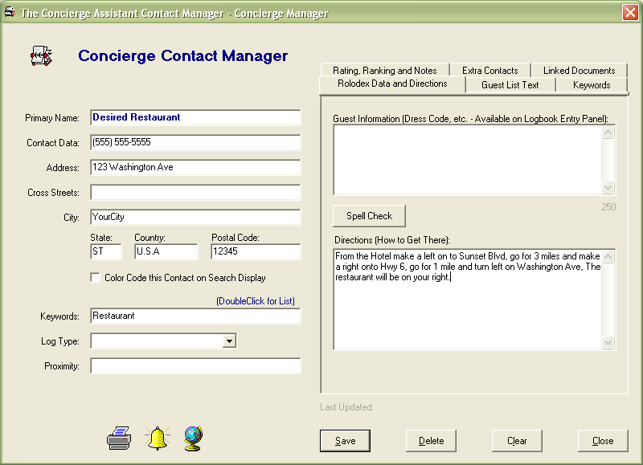

In the Administration Screen go to “Logbook Categories” and select the category to be linked, and the click “work with data entry panel”

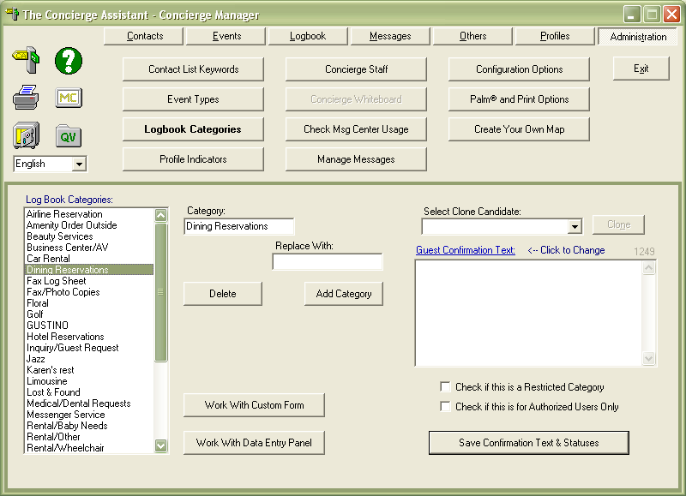

Select or create a field call “directions” and click “Link C2DE” button, select directions, hit “OK” and then click “add” (you will see a number 6 on the left of the field), click “Save data entry design”

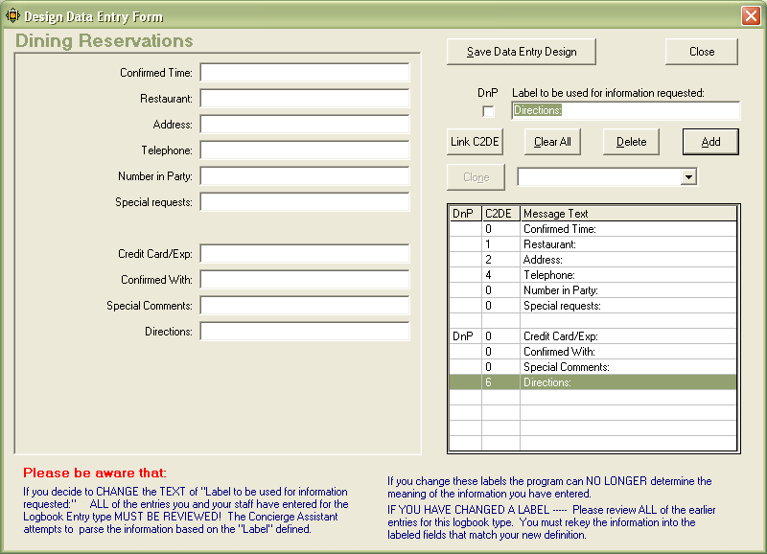

In the “Logbook Screen” select “add logbook entry”, select the linked category and use the Rolodex from the “Data entry form”, find the contact that we added directions and double click it, it will come down to your lower left on the screen, click the arrow and the linked elements will self populate. Once you have them there you can print confirmations, itineraries, vendor forms and miscellaneous forms with directions.

